Curriculum vitae
BUI XUAN TRUONG
PERSONAL DETAILS
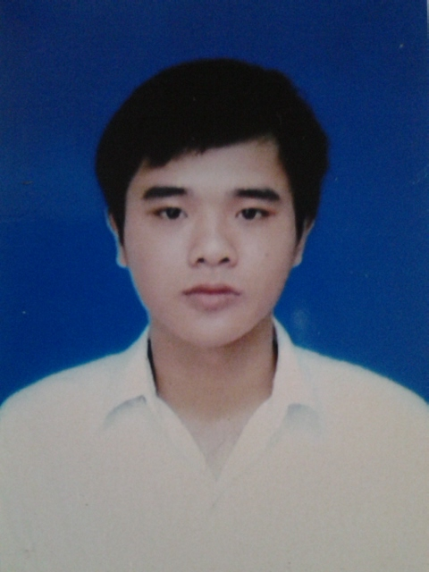 | Full Name: | Bui Xuan Truong
 | Job Titles: | Junior Developer
 | Date of Birth: | June 13st 1994
 | Place of Birth: | Thai Binh, Vietnam
 | Gender: | Male

SUMMARY INFORMATION
Have 3 years experiences on developing software (C, C++, C#, Qt, Qt UI, QML, Java, Android)
Have experiences and deep understanding on developing software for Media sevrice in Vehicle,Linux system, Embedded system, IOT
Have experiences in testing project in A-Spice process (ENG.6 – ENG.7)
Have experiences working with Product Project, IOT
Have experiences work with hardware, communicate between hardware and software
Work with Bluetooth, Android (System Service, Beacon Service, module communicate), embedded…

EDUCATION HISTORY
From: 09/2016  To: 10/2016 | University: Ha Noi University of Science and Technology, Vietnam  Major: Electronic Telecommunication Engineering  Degree/Qualification: Scholarship to the Microchip company  Graduated with honors in scientific research  Traning student
From: 10/2016  To: 6/2017 | University: Ha Noi University of Science and Technology, Vietnam  Major: Electronic Telecommunication Engineering  Job Description:  - System design for HF communication System  - Coding  - Traning student

EMPLOYMENT HISTORY
From: 06/2017  To: present | Company: FPT software  Job Title: Junior Developer  Job Description:  - Requriment analysic  - Create High level design, Low level design  - Coding  - Unit test  - Integration test

PROJECT REFERENCE AND SKILL SET

ATTENDED PROJECTS
From: 03/2016  To: 10/2016 | Project: | Fire warning for building
 | University: | Ha Noi University of Science and Technology, Vietnam
 | Project size: | 10
 | Project position: | Hardware design, system design, Developer
 | Responsibility: | - Refactoring and Development for a Fire Warning System in Building System of Fire Department.
 | Project description: | The project aims to maintain system developed by us
 | Used programming languages: | - C,C#, Java anrdroi, Html
 | Used programming technologies: | - Ethernet, 3g, Wifi, Wifi hotspot, Cloud service, Internet comunication, …
From: 11/2016  To: 6/2017 | Project: | HF Digital communication
 | University: | Ha Noi University of Science and Technology, Vietnam
 | Project size: | 6
 | Project position: | Hardware design, system design, Developer
 | Responsibility: | - Design and Development for HF Digital Communication System of ‘Ministry of Industry and Trade’.
 | Project description: | The project aims to design and develop system HF communication  service of the sea developed by us
 | Used programming languages: | - C/C++, Verilog for FPGA
 | Used programming technologies: | - Digital Telecommunication technology, Data encrypt, EA security, Internet comunication, …
From: 8/2017  To: 2/2017 | Project: | MIB3
 | Company name: | FSOFT
 | Project size: | 45
 | Project position: | Developer
 | Responsibility: | - Refactoring and Maintenance applications and HMI for a Camera Control System in Automobile of Panasonic.
 | Project description: | The project aims to maintain most automotive application and meidia module developed by us and partner
 | Used programming languages: | - C/C++, Java
 | Used programming technologies: | - Ethernet, 3g, Wifi, Wifi hotspot, …  - Multithread, KIPC interface, mutil call….
From: 02/2018  To: 05/2018 | Project: | A1 Platform
 | Company name: | FPT SOFTWARE
 | Project size: | 70
 | Project position: | Developer
 | Responsibility: | - Design, control HMI and fix Bug, support team  - Git, SVN and redmine manage for project
 | Project description: | The project aims to maintain most automotive application and HMI module developed by other and partner
 | Used programming languages: | C, C++
 | Used programming technologies:
From 05/2018  To: 7/2018 | Project | NSTEX
 | Company name | VTI VIET NAM
 | Project size | 7
 | Project position: | Developer
 | Responsibility: | - Design, Development
 | Project description: | Developed monitor system for steel production line in manufacturing companies of Japan
 | Used programming languages: | C++
 | Used programming technologies:
From 07/2018  To: 12/2018 | Project | RS Receiver
 | Company name | VTI VIET NAM
 | Project size | 8
 | Project position: | Developer
 | Responsibility: | - Design, Development
 | Project description: | Developed QR code scaner application to filter data scan from scan device
 | Used programming languages: | C++
 | Used programming technologies:

INFORMATION TECHNOLOGY SKILLS
Experiences: |  | 0: 0 month | 2: 6 – 12 months |  |  | 4: 2 – 5 years
 |  | 1: 1 – 6 months | 3: 1 – 2 years |  |  | 5: > 5 years
Last used: |  | Last year used
Expert level: |  | 1: Beginner Level | 3: Sometimes have to use manuals |  |  | 5: Expert Level
 |  | 2: Always have to use manuals | 4: Can solve problems
 |  |  | Experiences | Last used | Expert level
 |  |  | Experiences | Last used | 1 | 2 | 3 | 4 | 5
Platform
 | Linux |  | 4 | 2018 |  |  | X
 | Windows |  | 5 | 2018 |  |  |  | X
Database
 | MS SQL Server |  | 1 | 2016 |  | X
 | SQLite |  | 2 | 2016 |  | X
 | Firebase |  | 2 | 2017 |  |  | X
Programming
 | C/C++/C# |  | 4 | 2018 |  |  |  | X
 | Java |  | 3 | 2016 |  |  | X
 | Python |  | 1 | 2017 | X
 | Java/Xml for android |  | 4 | 2018 |  |  |  | X
 | Cotlin for android |  | 1 | 2018 |  | X
 | Qml |  | 3 | 2017 |  |  |  | X
Tools/IDE
 | Microsoft Visual Studio |  | 4 | 2018 |  |  |  | X
 | Android Studio |  | 4 | 2018 |  |  |  | X
 | Notepad ++ |  | 4 | 2018 |  |  |  | X
 | MplabX IDE |  | 4 | 2017 |  |  | X
 | Arduino IDE |  | 4 | 2017 |  |  |  |  | X
 | Atmel Studio |  | 2 | 2016 |  |  | X
 | Matlab |  | 4 | 2017 |  |  |  |  | X
 | Qt creator |  | 3 | 2018 |  |  |  | X
 | Astah Community |  | 4 | 2016 |  |  |  | X
 | Enterprise Architect |  | 2 | 2018 |  |  |  |  | X
 | Vector cast |  | 1 | 2018 |  |  | X
 | Git |  | 3 | 2018 |  |  | X
 | SVN tool |  | 2 | 2018 |  |  | X
Others

FOREIGN LANGUAGE
Experiences: |  | 0: 0 month | 2: 6 – 12 months |  |  | 4: 2 – 5 years
 |  | 1: 1 – 6 months | 3: 1 – 2 years |  |  | 5: > 5 years
Last used: |  | Last year used
Expert level: |  | 1: Beginner | 3: Fluent |  |  | 5: Translator
 |  | 2: Conversational | 4: Expert
 |  |  | Experiences | Last used | Expert level
 |  |  | Experiences | Last used | 1 | 2 | 3 | 4 | 5
Languages
 | English |  | 4 | 2018 |  | 2

